*Shortcuts
*
*
*
*
* ctor = constructor
* cw=console writelike
* ctrl k ctrl c = for commenting auto
* foreach double tab
* try -double tab= try catch
* prop - double tab - property
*ctrl-r + ctrl-r rename all in one click
* shift-alt-b -->jump where the method is
* shift-alt-w L --> makes one div
alt-w L clears all tabs
* f12 – will go to that specified object
* alt-enter in constructor on field and it creates the read only good stuff
* 3X /= shortcut
* override - to make an override method
* alt-Enter, Enter..usually it does the stuff for you
*
*
*
* Debuggings
*
*
*
*
* f5 run in debug mode
* f9 breakpoint
* f10 go into function
* f11 go out of fuction
* shift f5 get out of debug mode
*
* Fast Navigation
*
* ctrl tab = move between classes
*

Version Control :

creating Branch:

*go to Team Explorer
*Branches
*New Branch
*branch from Master mostly
*push branch

branch merging
* go to master branch
* synchronize master branch
* go to your branch
* go to branches in visual studio
* click on merge
* select from master
* click merge button
* after merge is completed go to home
* click sync
* click sync link

Commiting before branch merging
*go to changes and commit

Tools:
- Agent Ransack..software to see where a certain part of code repeats in other places

1.When you want to pass model, from view to controller (Input, asp controller etc)=usually is a httppost.
2. When you want to pass model, from controller to view (@Model.Name, etc..), usually is httpget
3. when u want to pass only a string , or a property of a model, you just use FromBody, and you don’t have to serialize the model (see AccountController-Registration step2, 3, also the views separate, and in index)
4. When trying to find something in db, usually you make a constructor, then you initialize a db context and call what you want
5. it is possible to inject a Database<Handler> when you don’t want to use a constructor…
Gen : UserSettings: LeftSideBar:
@{
var dbUser = DatabaseHandler<SwapLanguage.DataAccessLayer.Model.User>.Get(a => a.Email == User.Identity.Name);
}
6. the logic of properties, add in the model.
7. if u need a for each for the model. Make the logic in the view.
8. If you need to find an AuthenticatedUser based on ID, you can find him with Injecting UserManager:
@inject UserManager<User> UserManager
@{
User fullUser = null;
if (User.Identity.IsAuthenticated)
{
fullUser = UserManager.FindByNameAsync(User.Identity.Name).Result;
}
}

It is basically like a DbHandler, for User…except it requires that the user is authenticated.
9. You don’t have to return a partial everytime you use, since you use index to return partial.
You need to return Partial on Controller action if you use it for something for Ajax.

Regards the Database:

masterdata is static data
used for loading stuff to website
and assigning to the country etc
website schema is dynamic schema
that is preparation for microservices architecture
the wanttolearnlanguages should be added as hashset in the constructor
it is not obligatory, but it should, i needed to miss it
Example of how Entity Builder works:
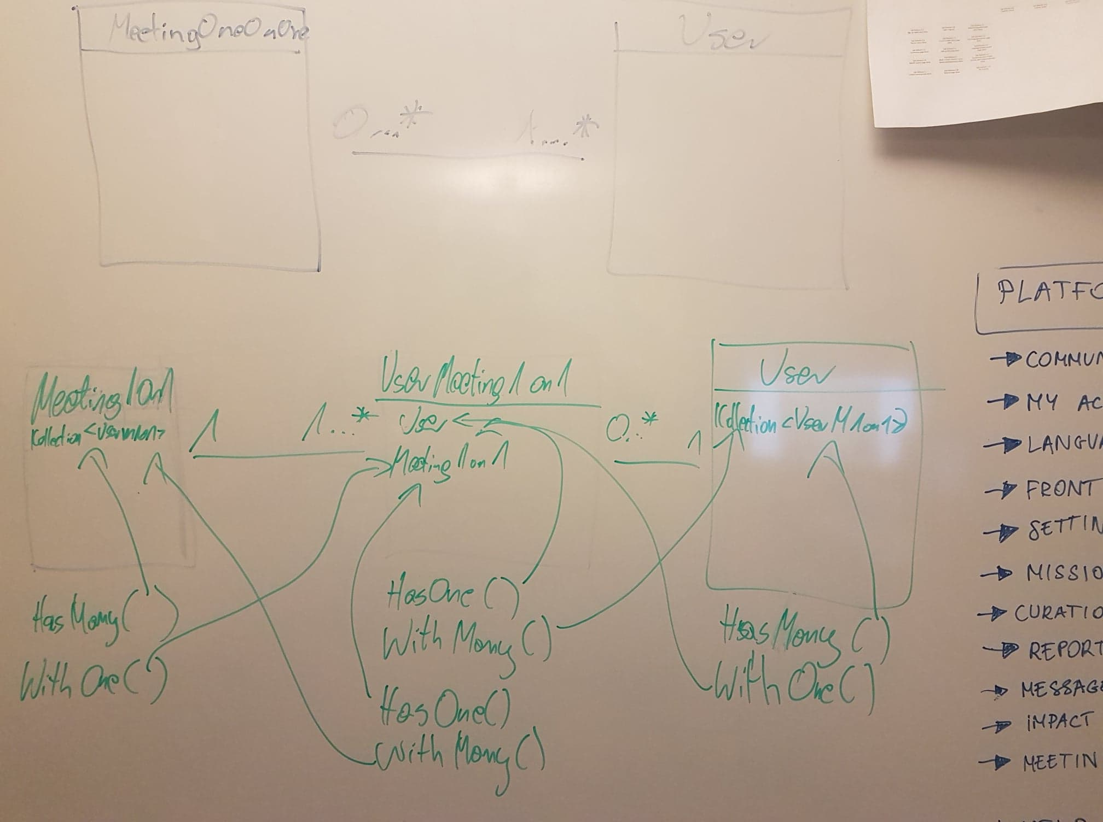
Figure 1DatabaseBuilder –Schema

Meeting1On1 0..* ………1..* User ( User can have 0 to Many MeetingOneOnOne
(MeetingOneOnOne can have 1 to Many Users)
Because is many to many..we need a Joint Table…(as how we learned in school)
So this becomes:
Meeting1On11…….1..*UserMeeting1On10..*……..1 User
(ICollection<UserM1on1) User, M1On1 ICollection<UserM1On1
Meeting1On1 (ICollection<UserMeeting1On1):
Has 1 to Many UserM1On1 with One Meeting1On1

User (ICollection<UserMeeting1On1):
Has 0 to Many UserM1On1 with One User

UserMeeting( virtual user, virtual M1On1)
Has One user with Many UserMeeting
Has one Meeting with Many UserMeetings

builder.Entity<MeetingOneOnOne>()
.HasOne(a => a.Mission)
.WithMany(a => a.MeetingsOneOnOne);
builder.Entity<MeetingOneOnOne>()
.HasMany(a => a.Users)
.WithOne(a => a.MeetingOneOnOne);

builder.Entity<User>()
.HasMany(a => a.MeetingsOneOnOne)
.WithOne(a => a.User);

builder.Entity<UserMeetingOneOnOne>()
.HasOne(a => a.User)
.WithMany(a => a.MeetingsOneOnOne);
builder.Entity<UserMeetingOneOnOne>()
.HasOne(a => a.MeetingOneOnOne)
.WithMany(a => a.Users);

Debugging On FrontEnd-Ajax.
When debugging to see why the javascript stuff doesn’t work, you have to inspect the page, and shee in console- XHR, Requests/Logs, and everything to see why it says all of that…
Debugger: shows the debug

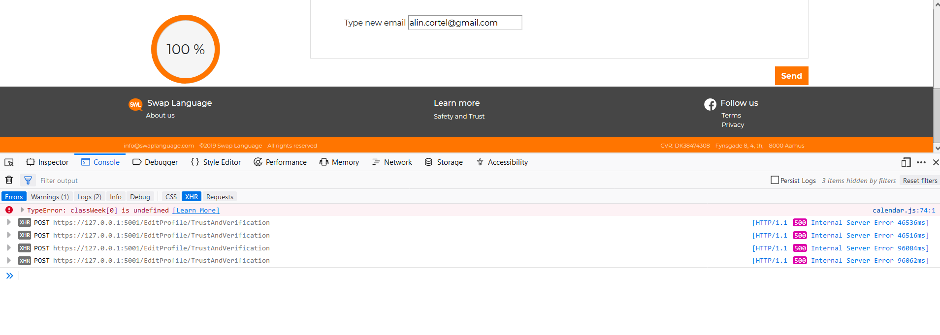

Example of handling the Error Text Sign Up Fix..
(Ajax Calls commit 41c60318 2-20-2019
Error on page, not redirecting error page
Old way of handling:
In account controller: when the shit goes bad , you return a StatusCode(4001) if u want…but better to do like this:

this ::::: on Account Controller Login:

Old type:

if (string.IsNullOrWhiteSpace(model.LoginEmail) || string.IsNullOrWhiteSpace(model.LoginPassword))
return StatusCode(4001); // email/password empty

var user = await _userManager.FindByEmailAsync(model.LoginEmail);
if (user == null)
{
return StatusCode(4002); //wrong username/password
}

In the sign in modal, for example: <p class="errorText" id="signInErrorText"></p>

You make a normal css errorText, and normal id
Ex in in signup With Email mOdal: <p class="errorText m-1" id="emailErrorText"></p>
And in the js..for example for the signIn.JS
$("#signInWithEmailForm").submit(function (e) {
$.ajax({
url: '/Account/Login',
type: 'POST',
contentType: 'application/x-www-form-urlencoded',
data: $(this).serialize(),
success: function (data, textStatus) {
window.location.href = data.redirect;
},
error: function (jqXHR, textStatus, errorThrown) {
if (jqXHR.status === 4001) {
$("#signInErrorText").text("You need to fill in both email and password");
} else if (jqXHR.status === 4002) {
$("#signInErrorText").text("Wrong email or password");
} else {
windows.location.href = jqXHR.redirect;
}
}
});

e.preventDefault();
});

Proper Way:
Instead of returning a 4001 or such..you return a ..:
Example in Login Action in Account Controller: you return a statusCode

if (string.IsNullOrWhiteSpace(model.LoginEmail) || string.IsNullOrWhiteSpace(model.LoginPassword))
return StatusCode((int)HttpStatusCode.ExpectationFailed); // email/password empty

var user = await _userManager.FindByEmailAsync(model.LoginEmail);
if (user == null)
{
return StatusCode((int)HttpStatusCode.FailedDependency); //wrong username/password
}

And since you know what code is what ExpectationFailed-417, and other is 424,
In Ajax, SignIn.Js
$("#signInWithEmailForm").submit(function (e) {
$.ajax({
url: '/Account/Login',
type: 'POST',
contentType: 'application/x-www-form-urlencoded',
data: $(this).serialize(),
success: function (data, textStatus) {
window.location.href = "/Front";
},
error: function (jqXHR, textStatus, errorThrown) {
console.log("status" + jqXHR.status);
console.log("status" + jqXHR.redirect);
if (jqXHR.status === 417) {
$("#signInErrorText").text("You need to fill in both email and password");
} else if (jqXHR.status === 424) {
$("#signInErrorText").text("Wrong email or password");
} else {
window.location.href = jqXHR.redirect;
}
}
});

e.preventDefault();
});
Commit 968c947b
2/20 – check acc controller, EditProfile- LangLocPartial, in shared RegProcessBoxStep2, and in js Registration,

//STEP 1
function processFormRegisterStep1(e) {
$.ajax({
url: 'Account/RegistrationStep1',
type: 'POST',
contentType: 'application/x-www-form-urlencoded',
data: $(this).serialize(),
success: function (dataReceived) {
if (dataReceived === "OK") {
console.log("Account/RegistrationStep1 processed successfully");
$('#registrationStep2LanguageName').text($("#RegStep1Language").val());
$('#registrationProcessBoxStep1').modal({
backdrop: true,
keyboard: true
});
$('#registrationProcessBoxStep1').modal('hide');

$('#registrationProcessBoxStep2').modal({
backdrop: 'static',
keyboard: false
});
$('#registrationProcessBoxStep2').modal('show');
}else
{
$("#errorMessageRegistrationBox1").text(dataReceived);
}

},
error: function (dataReceived) {
//console.log("Account/RegistrationStep1 processed with errors");
//$('#registrationProcessBoxStep1').modal({
// backdrop: true,
// keyboard: true
//});

//$('#registrationProcessBoxStep1').modal('hide');

//$('#registrationProcessBoxStep2').modal({
// backdrop: 'static',
// keyboard: false
//});
$("#errorMessageRegistrationBox1").text(dataReceived);
}
});

e.preventDefault();
}

Sign up with fb email:
On SingUpWithEmail Modal

<form id="facebookSignUpEmail" method="post" asp-controller="Account" asp-action="ExternalLogin">
<input name="provider" type="hidden" value="Facebook" />
<small>Sign up with <small class="font-text-color-orange"><a href="#" onclick="$('#facebookSignUpEmail').submit()">Facebook</a></small> @*or <small class="font-text-color-orange">Google</small>*@</small>
</form>

Commit – googlemapsapipicker
pac-input = place autocomplete basically…
Gen : <li><strong>Location</strong><input type="text" class=" ml-4 mb-2 form-control custom-form-control-no-border-radius custom-form-control-orange custom-form-control-orange:focus form-control-sm custom-form-control-meeting-modified pac-input" placeholder="Choose location" asp-for="Location" />

Js: place autocomplete

function initMap() {
var inputs = document.getElementsByClassName('pac-input');
for (var i = 0; i < inputs.length; i++) {
console.log("Google Maps API Init: " + $(inputs[i]).attr('class'));
var autocomplete = new google.maps.places.Autocomplete(inputs[i]);

// Set the data fields to return when the user selects a place.
autocomplete.setFields(['address_components', 'geometry', 'icon', 'name']);
autocomplete.addListener('place_changed', function () {
var place = autocomplete.getPlace();
if (!place.geometry) {
// User entered the name of a Place that was not suggested and
// pressed the Enter key, or the Place Details request failed.
input.value = "";
return;
}
});
}
}

Make bold link on current page:
var currentPage = ViewBag.CurrentPage;
<li class="nav-item">
@if (currentPage == "LastInformation")
{
<a class="nav-link text-dark nav-link-sidebar-modified font-weight-bold" id="LastInformationNeeded" asp-controller="EditProfile" asp-action="LastInformationNeeded">Complete Your Profile</a>
}
else
{
<a class="nav-link text-dark nav-link-sidebar-modified" id="LastInformationNeeded" asp-controller="EditProfile" asp-action="LastInformationNeeded">Complete Your Profile</a>

}

And on controller actions in editprofile ex:
On index: ViewBag.CurrentPage = "EditProfile";
On Location:
ViewBag.CurrentPage = "LanguagesLocation";

Dynamic Languages and location has an interesting way to handle with ajax..the not found stuff…
Editprofilecontroller/ lang and locations partial/ lang location js

Debugging With Inspector: it is always good to check with Inspector exactly what lines are missing and what not…helps quite a lot..
NOTE::::::::::::
When you have a button Submit: if in an ajax call you need a model to pass, you use a form, and on the button> < form=”theidoftheform” is a must…>
When you have a button submit: if in an ajax call you need to pass only an event, use onclick=”idFunctionAjax”

Cand ai un playlist… poti sa faci si un IEnumerable caruia ii asociezi un playlist sa poti folosi LinQ
private readonly List<PlayerNode> _players = new List<PlayerNode>();

public IEnumerable<PlayerNode> PlayerList => _players;

public PlayerNode GetByName(string Name)
{
PlayerNode pn = _players.Find(x => x.Name == Name);
if (pn != null)
return pn;

return new PlayerNode("");
}

Ex: sa iti transformi datele din clasa in Json:
public class MapTeamNode : NodeBase
{
public readonly int Score;
public readonly int TimeoutsRemaining;
public readonly int MatchesWonThisSeries;
public readonly string Name;

internal MapTeamNode(string JSON)
: base(JSON)
{
Name = GetString("name");
Score = GetInt32("score");
TimeoutsRemaining = GetInt32("timeouts_remaining");
MatchesWonThisSeries = GetInt32("matches_won_this_series");
}
}

Downloading a file :
Controller :
public IActionResult DownloadFile(string file)
{
file = @"Normalization Forms.docx";
if (file ==null)
{
throw new NotImplementedException();
}

string wwwrootPath = _hostingEnvironment.WebRootPath;

IFileProvider provider = new PhysicalFileProvider(wwwrootPath);

FileInfo fileinfo = new FileInfo(Path.Combine(wwwrootPath, file));
var readStream = fileinfo.OpenRead();

var mimeType = "application/vnd.ms-excel";
return File(readStream, mimeType, file);

}
And in view..use just @Url.Action(“DownloadFIle”,”ControllerName”);

